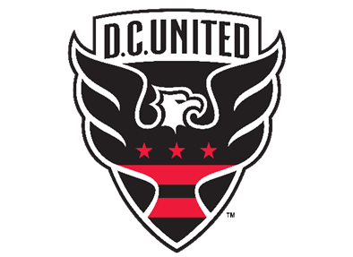

DC UNITED 2026 ORDER FORM

NAME: __________________________________ PHONE NUMBER: _________________________
EMAIL: _________________________________________ORDER DATE: ____________________

Opponent | West Sideline (sections 201-203 & 208-210) | Middle Endline (sections 115-119) | Club (section C1) * | # of Tickets | Price Per Ticket | Total Paid/Initials
Chicago 5/13 | $51.75 | $40.75 | $229.00
St. Louis 5/16 | $55.00 | $44.00 | $229.00
Montreal 5/23 | $51.75 | $40.75 | $264.00
Toronto 7/25 | $55.00 | $44.00 | $229.00
Nashville 8/1 | $51.75 | $40.75 | $264.00
New England 8/19 | $51.75 | $40.75 | $264.00
LAFC 8/29 | $55.00 | $44.00 | $264.00
Columbus 9/9 | $51.75 | $40.75 | $229.00
Atlanta 9/12 | $55.00 | $44.00 | $264.00
Charlotte 9/19 | $55.00 | $44.00 | $264.00
New York 10/14 | $51.75 | $40.75 | $264.00
Cincinnati 10/24 | $55.00 | $44.00 | $264.00
New York City 11/17 | $55.00 | $44.00 | $264.00

*The Club Level is all inclusive of Food and Beverage/Alcohol, provides access to the indoor club lounge, and provides padded seating next to the player benches.
Tickets are to be prepaid and ordered based on availability. Tickets will be sent to your email address. Please download the Ticketmaster App on your smartphone or computer to download and receive your tickets.

