

Local Attractions  Updated: 4/6/2026 | ELIGIBILITY: All Active Duty, Retired, Reservists, National Guard, DoD, Alumni Association, NAAA, and full-time USNA Contractors and Eligible Veterans.
***************ALL SALES ARE FINAL******************NO REFUNDS******************NO EXCHANGES******************
Closed Weekends and Holidays. Prices Subject to Change Without Notice

MOVIE TICKETS: MWR Price
AMC TICKETS – Annapolis Mall $10.00
REGAL CINEMAS UNRESTRICTED $10.00

TEE TIME GOLF SUPER PASS $84.25
Super Pass is your all-in-one ticket to huge savings at nearly 1,000 golf courses. Enjoy free greens fees, exclusive deals, senior discounts, and weekend specials all year long. Explore all our courses and all our deals in 20 states including: Connecticut, Delaware, Florida, Georgia, Indiana, Kentucky, Maine, Maryland, Michigan, New Hampshire, New Jersey, New York, North Carolina, Ohio Pennsylvania, South Carolina, Tennessee, Vermont, Virginia, and West Virginia

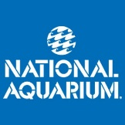
MARYLAND

NATIONAL AQUARIUM in BALTIMORE

www.aqua.org

These tickets do not include the IMAX Theater. The IMAX may be purchased at the aquarium for an additional fee.

Gate Price MWR Price
Adults $49.95 $44.75
Military Only $49.95 $39.25
Children (5-20) $39.95 $36.00
Seniors (70+) $39.95 $36.00

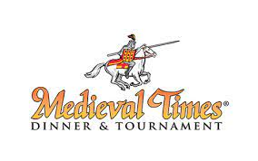
MEDIEVAL TIMES
Hanover, MD

Includes Royalty Upgrade

Gate Price MWR Price
Adult Admission $84.65 $63.00
Child (ages 2-12) $51.65 $41.25

 Maryland Zoo, Baltimore
www.marylandzoo.org
Gate Price MWR Price

Admission – (Ages 3 and up) $33.00 $27.00

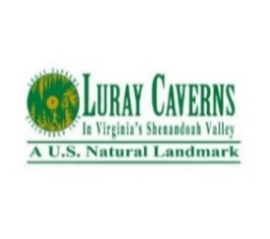
VIRGINIA

Luray Caverns
Luray, VA
www.luraycaverns.com

Gate Price MWR Price
Adults $36.00 $29.75
Children (6-12) $18.00 $15.50


COLONIAL WILLIAMSBURG
(Other ticket options available
upon request)

Multi day (Valid for any 3 days from 1st use within a 7 day period)
Adult $60.00 $
Youth (6 - 12 yrs) $18.00 $

Americas Triangle
Adult $123.00 $
Youth (6-12) $55.00 $


OCEAN BREEZE WATERPARK
Virginia Beach, VA

Gate Price MWR Price

Regular Admission Adult $58.29 $40.75
Regular Admission Child $47.29 $33.00
Season Pass $142.99 $77.00

 Virginia Beach, VA

Gate Price MWR Price
$83.24 $66.00

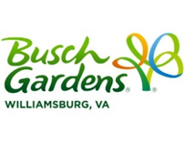

BUSCH GARDENS, Williamsburg, VA

Gate Price MWR Price
Busch Gardens $90.00 $61.00
Busch Gardens 1 day w DINE $124.99 $94.25
Busch Gardens MIL Pass $154.00 $137.75**
**• Valid for unlimited visits to Busch Gardens Williamsburg on regularly scheduled park operating days from September 16, 2025 through January 1, 2027. Also includes unlimited admission to Busch Gardens Williamsburg Howl-0-Scream and Christmas Town. Includes general parking.

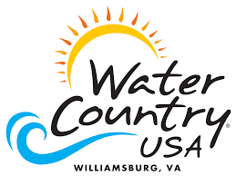 WATER COUNTRY USA, Williamsburg, VA

Gate Price MWR Price
BGW & WC – MILPASS $154.00 $137.75
**Includes all in the above MIL Pass description, plus valid for unlimited visits to Water Country USA on regularly scheduled park operating days May 9, 2026 through September 20, 2026

WASHINGTON, DC

Old Town Trolley Tour of D.C.
www.trolleytours.com.

Gate Price MWR Price

DC City Tour Adult $68.45 $42.75
DC City Tour Child $44.45 $33.00
DC/Arlington Adult $74.95 $57.75
DC/Arlington Child $49.95 $37.75

PENNSYLVANIA
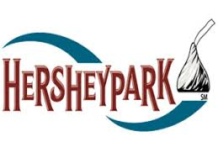
HERSHEYPARK Hershey, PA

Gate Price MWR Price

 Sesame Place, Langhorne, PA

Gate Price MWR Price
General Admission $75.95 $50.50
Military Pass $107.50

NEW YORK
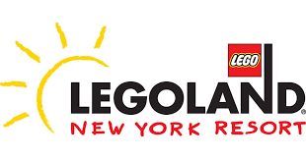 Gate Price MWR Price
Ages 2 and older $94.00 $56.00

CityPASS NYC: $137.75 (adults) $115.75 (child)

NEW JERSEY
 East Rutherford, NJ
Gate Price MWR Price
Nickelodeon Park (3+) $79.00 $50.50
Dreamworks** (3+) $99.00 $61.75
(Waterpark)

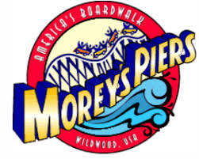 Wildwood, NJ
Gate Price MWR Price
Waterparks $67.00 $
Flex COMBO Pass $125.00 $


Gate Price MWR Price
4 Day Military Pass $499.00 $389.00
IKON Base Pass $949.00 $589.00
IKON PASS $1399.00 $899.00

Arapahoe Basin, Big Bear Mountain Resort, Blue Mountain, Copper Mountain Resort, Crystal Mountain, Eldora Mountain Resort, June Mountain, Mammoth Mountain, Palisades Tahoe, Schweitzer, Snow Valley, Snowshoe, Solitude Mountain Resort, Steamboat, Stratton, Sugarbush Resort, Tremblant, Winter Park, Aspen Snowmass, Sierra-at-Tahoe, Jackson Hole Mountain Resort, Big Sky Resort, Sun Valley, Alyeska Resort, Killington-Pico, The Highlands, Boyne Mountain, Snowriver Mountain Resort, Lutsen Mountains, Granite Peak, The Summit at Snoqualmie, Mt. Bachelor, Le Massif de Charlevoix, SkiBig3, Revelstoke Mountain Resort, RED Mountain, Cypress Mountain, Panorama Mountain Resort, Sun Peaks Resort, Sunday River, Sugarloaf, Loon Mountain, Camelback Resort, Blue Mountain Resort, PA, Taos Ski Valley, Deer Valley, Brighton Resort, Alta Ski Area, Snowbird, Snowbasin, Chamonix Mont-Blanc Valley, Megève Ski Area, Dolomiti Superski, Valle D'Aosta, Grandvalira Resorts Andorra, Kitzbühel, Ischgl, Zermatt, St. Moritz, Thredbo, Mt Buller, Coronet Peak, The Remarkables, Mt Hutt, Niseko United, Arai Mountain Resort, Shiga Kogen Mountain Resort, Mt. T, Myoko Suginohara, APPI Resort, Furano Ski Resort, NEKOMA Mountain, Zao Onsen Ski Resort, Yunding Snow Park, Mona Yongpyong, Valle Nevado.

